PHASE II: PROJECT PLANNING
Date | 06 November 2025
Team ID | NM2025TMID08097
Project Name | To supply Leftover Food to Poor
Maximum Marks | 4 Marks

Title: Project Planning for “FoodConnect – To Supply Leftover Food To Poor”

1. Objective
The Project Planning Phase establishes the foundation for designing and developing the FoodConnect system.
Its purpose is to analyze requirements, define data entities, plan security configurations, and design user access to ensure a stable and efficient Salesforce implementation.
This phase also identifies the logical structure, relationships, and user hierarchy necessary for smooth operations in the Salesforce Developer Edition.

2. Overview of the Planning Process
The planning phase involves four key components:
- Defining Core Entities and Relationships
- Designing Security and Data Sharing Models
- User Creation and Role Assignment
- Establishing the Development Timeline and Tools
This ensures the entire system aligns with both the technical feasibility and the social objectives of minimizing food wastage through automation.
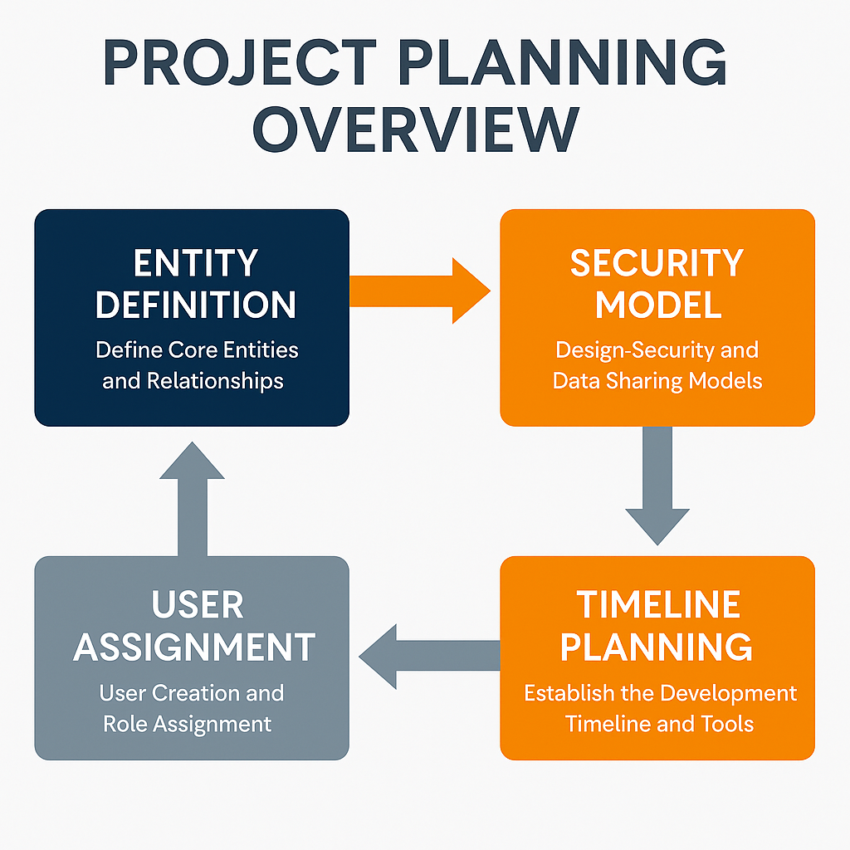

3. Core Entity Identification
The FoodConnect application is structured around five main custom objects, each representing a key component of the food redistribution process:
Object Name | Description | Relationships
Venue | Represents the food donor (restaurants, event halls, caterers). | Linked to Drop-Off Point and Task
Drop-Off Point | Represents the delivery location (NGO, shelter, etc.). | Linked to Venue and Volunteer
Volunteer | Represents individuals who collect and deliver food. | Linked to Task and Execution Details
Task | Represents specific donation and delivery actions. | Master-Detail with Execution Details
Execution Details | Represents records of completed deliveries. | Child of Task
Each object corresponds to real-world entities and ensures that food movement can be tracked from donor → volunteer → recipient with complete transparency.

4. Relationship Strategy
The relationships among these entities were designed to maintain referential integrity and data security:
Relationship Type | Object Pair | Purpose
Master-Detail | Task → Execution Details | To automatically delete related child records when the parent is deleted.
Lookup | Volunteer → Drop-Off Point | To allow flexible volunteer assignment.
Formula | Drop-Off Point → Venue | To calculate real-time distance between donor and recipient.
This structure supports data consistency and allows the use of automation tools (Flows, Triggers) effectively.

5. Security and Profile Planning
The Salesforce Security Model was implemented to ensure that data access is role-based and adheres to the principle of least privilege.

5.1 Custom Profiles Created
Profile Name | Description | Access Level
Volunteer Profile | Used by field volunteers who collect food. | Read, Create, and Edit permissions on specific objects.
NGO Admin Profile | Used by organization administrators. | Full CRUD access to all objects and setup features.
Each profile was cloned from the standard Salesforce profiles and customized to restrict unnecessary privileges.

5.2 Public Groups
To streamline record visibility and sharing:
Public Group | Members | Purpose
Isha Volunteers | Active volunteer users | Handles local food collection.
NGO Coordinators | Admin-level NGO users | Oversee entire operations and reporting.

6. Data Access and Sharing Rules
To maintain control over who sees what data, Criteria-Based Sharing Rules were applied:
- If Distance < 15 km, record is shared with Isha Volunteers group.
- If Distance > 30 km, record is shared with NGO Coordinators group.
This ensures that:
- Volunteers only access nearby delivery points.
- NGO Admins view organization-wide data for reporting.
Rationale: This configuration avoids data clutter, maintains efficiency, and provides users with only the relevant records.

7. User Creation and Role Assignment
User creation followed a systematic process within the Salesforce setup:

7.1 Procedure
- Navigate to Setup → Users → New User.
- Enter details like First Name, Last Name, Email, and Username.
- Assign a Salesforce Platform License to Volunteers.
- Assign a Salesforce License to NGO Admins.
- Allocate profiles and public groups accordingly.

7.2 User Hierarchy
Role | Assigned Profile | Group | Privileges
NGO Coordinator | NGO Admin | NGO Coordinators | Full Access
Volunteer | Volunteer Profile | Isha Volunteers | Limited Access
System Admin | Standard Admin | N/A | Full Setup Access

8. Environment Setup and Configuration
This part ensures a consistent working environment for testing and future scalability.
Steps:
- Developer Edition account created from developer.salesforce.com/signup.
- Verified access and enabled Salesforce Lightning Experience.
- Set organization branding (App Name: FoodConnect).
- Installed essential tools like Flow Builder, App Manager, and Schema Builder.
- Created Custom Tabs for easy navigation to all entities.
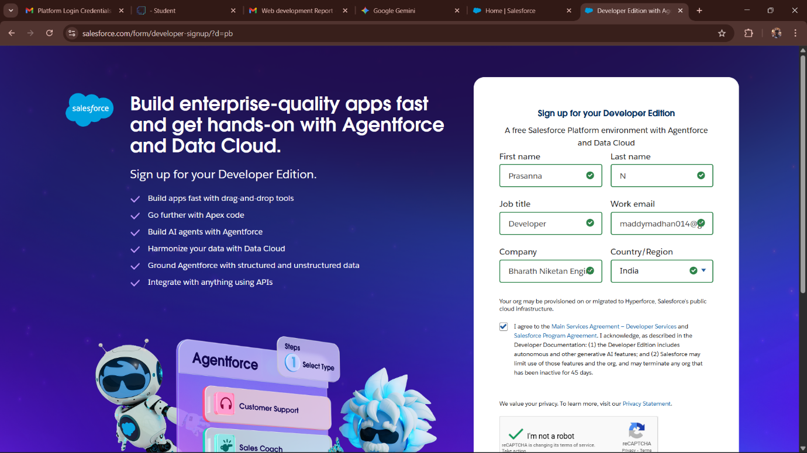

9. Project Timeline and Resource Plan
Phase | Duration | Key Deliverables
Ideation | 2 Days | Problem Definition, Brainstorming
Planning | 3 Days | ERD, Security Model, User Creation
Requirement Analysis | 4 Days | Object and Field Configuration
Design & Implementation | 5 Days | App, Flow, Dashboard
Testing & Deployment | 2 Days | Validation, Reporting

10. Tools and Resources Used
Tool | Purpose
Salesforce Lightning App Builder | UI and App Design
Flow Builder | Automation of Data Entry
Apex Trigger | Distance Calculation
Dashboard Builder | Data Visualization
Schema Builder | Object Relationship Design
SmartInternz Platform | Project Mentorship and Submission

11. Expected Outcomes of the Planning Phase
At the end of the Project Planning Phase:
- Data models and relationships were finalized.
- User profiles and permissions configured.
- The technical environment was fully prepared.
- Clear workflow and access strategy established.
This ensures a solid foundation for the upcoming Requirement Analysis and Implementation Phases.
[Figure 2.7: Planning Workflow Diagram – Setup to Implementation]

12. Summary
The Project Planning Phase serves as the blueprint for the successful execution of the FoodConnect project.
By organizing the development environment, defining roles, and establishing data relationships, it transforms the initial concept into a structured, scalable framework.
Salesforce’s flexibility enables FoodConnect to adapt as the project grows — making this phase not just a preparation stage, but a roadmap for sustainable impact.

